Overview

RebuildDuctdefinition :
Some Conduits are related with more than one PGEDuctDefinition/DuctDefinition in Gis, and this should never happen.

Below is the logic:
-Delete related pgeductdef records for subtypes ductbank and CIC.
- Delete any associated records and replacing them with the correct ones from input ductdefinition table (This table contains the ductdefinition records of WP Deliveries of 1-8) which comes under this condition ((SUBTYPECD NOT IN ('1','3') AND and the conduit feature not edited/created by mapper)
-Generate number of pgeDuctdefinition records based on conductsystem-ductcount
If any conduits not found in the input filegeodatbase table, these conditions will be reported in the log for manual fix.

1.) Open ArcMap in citrix and connect to the production database and create a session, open the session, save and close the created session.
2) Installation setup
Copy PGEElecCleanup_Setup.msi, setup.exe, CV_Duct Definition.gdb and MappersList.txt in your local drive.
Click on setup file “PGEElecCleanup_Setup” to install and it asks for the path to install.
Copy the MappersList.txt files into the same directory the .exe file was installed

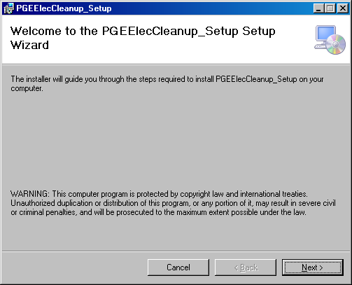

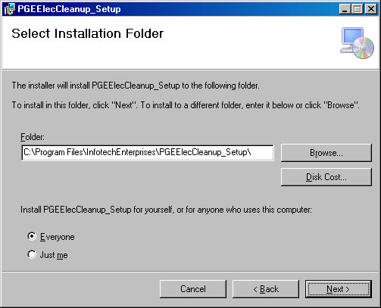

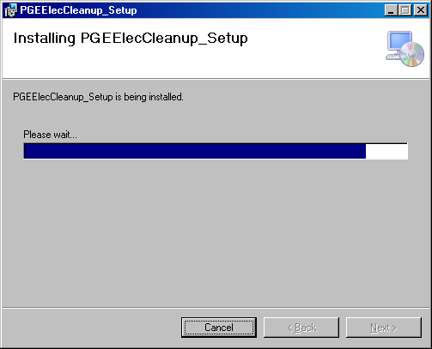
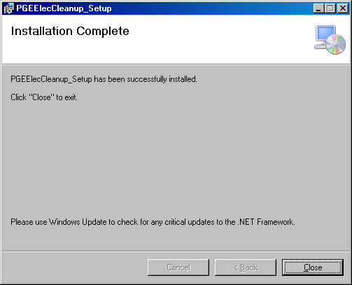
Click on PGEElecCleanup.exe from installed path. It opens below GUI.
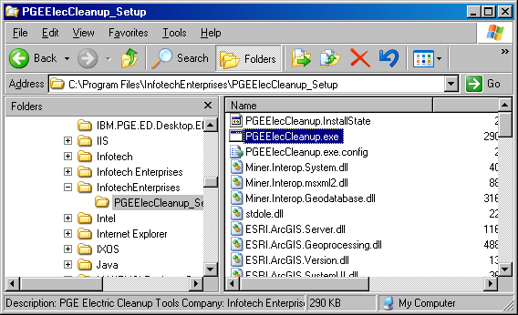

Select tab Database->Connection, following Spatial Database connection GUI form will be opened
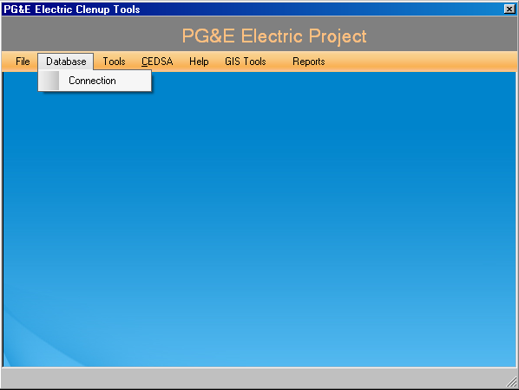

-Provide the SDE connection details (Replace production database name inplace of edgism2q), username and password.
-Select the version which is created in Arc Map to run the tool.

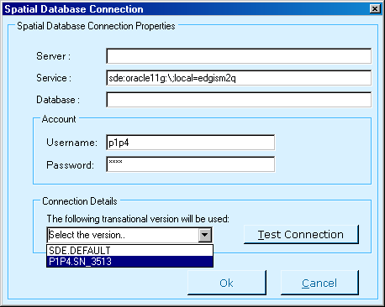
Test connection established for a selected versioned database, Click on OK if the test succeed.
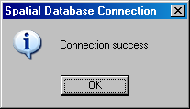
Select tab Tools->RebuildDuctDefinition,it will opens below GUI.
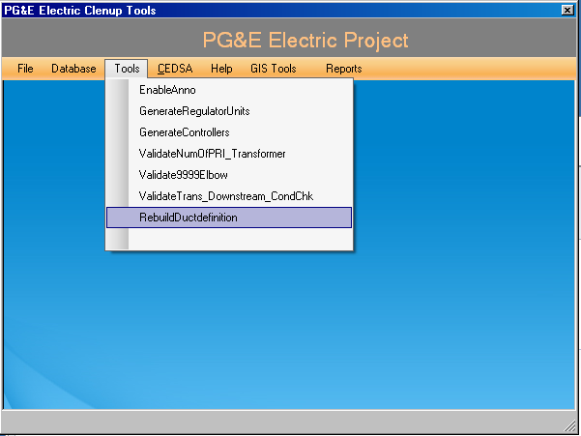

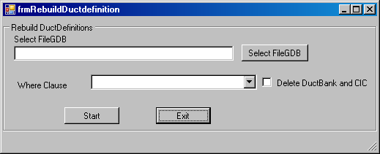
Click on SelectFileGDB button and browse the file ‘CV_Duct Definition.gdb’ which is copied locally. It take 2 to 3 mints to popup below interface.
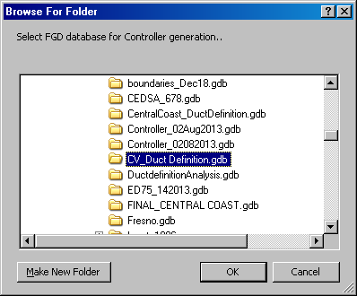
Once browse the gdb file, based on feature count in conduitsystem featureclass it will divide into parts and added in to combo box like below
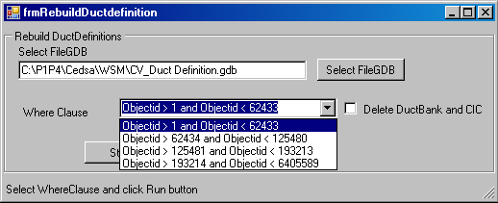
Select where clause option and then click start button to execute the tool.
Note: For first execution tool need to be run by selecting ‘Delete DuctBank and CIC’ option and remaining executions tool need to be run without selecting ‘Delete DuctBank and CIC’ option
Bellow message box will popup on completion of tool execution.
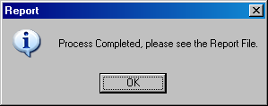
Log files will be generated at path C:\PGE_Reports.
After Verifying the tool results this session will need to be posted to default through GDBM.
DeleteDuctdefinition table data: Truncate table Ductdefinition table using below script. Connect EDGIS schema through sqlplus and run below script.
TRUNCATE TABLE Ductdefinition;
COMMIT;
TRUNCATE TABLE A62;
COMMIT;

